**PRACTICE PROGRAM SECTION 5 :**

**1 ) WAVELENGTH :**

import java.util.Scanner;

public class Main

{

public static void main(String[] args)

{

double n;

Scanner x =new Scanner(System.in);

n=x.nextDouble();

if(n>=380&&n<450)

System.out.println("The Color is Violet");

else if(n>=450&&n<495)

System.out.println("The Color is Blue");

else if(n>=495&&n<570)

System.out.println("The Color is Green");

else if(n>=570&&n<590)

System.out.println("The Color is Yellow");

else if(n>=590&&n<620)

System.out.println("The Color is Orange");

else if(n>=620&&n<750)

System.out.println("The Color is Red");

else

System.out.println("The entered wavelength is not a part of the visible spectrum");

}

}

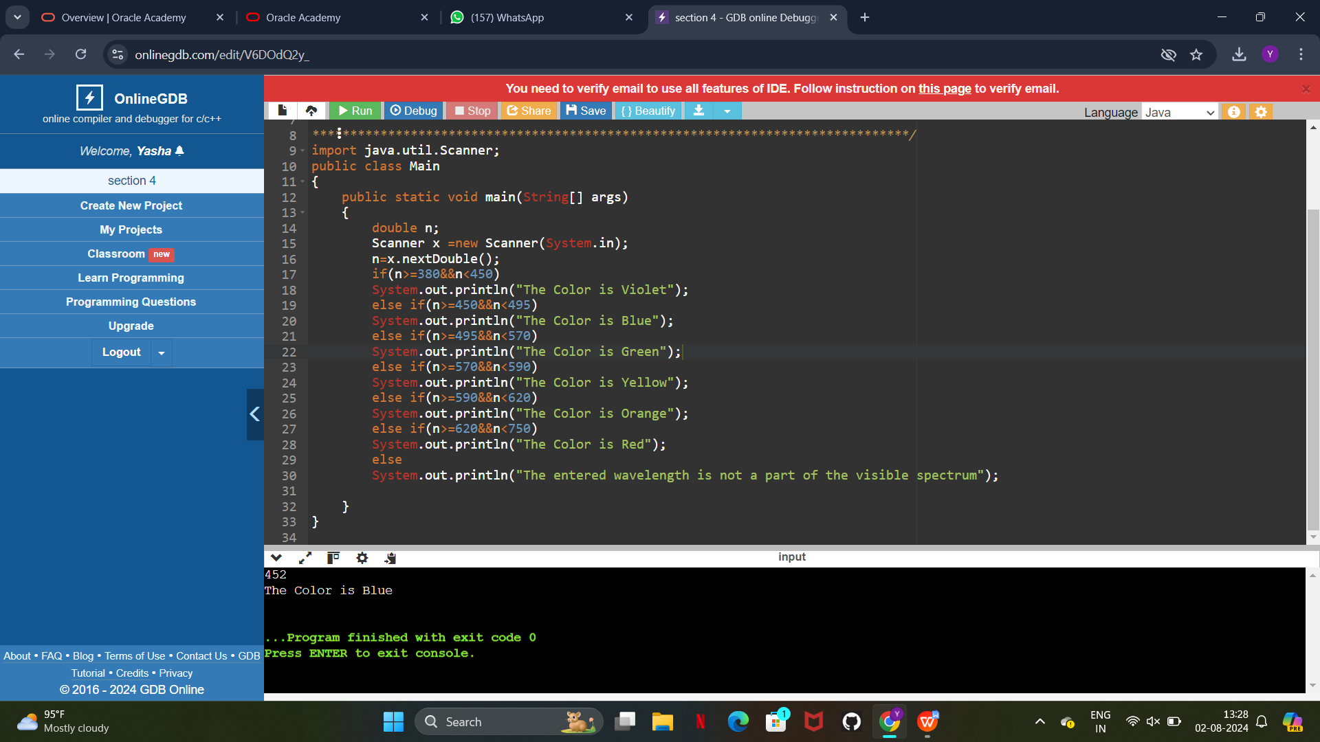

1. **TRAFFIC SIGNAL IF CONDITION :**

import java.util.Scanner;

public class Main

{

public static void main(String[] args)

{

int n;

Scanner x =new Scanner(System.in);

n=x.nextInt();

if(n==1)

System.out.println("Next Traffic Light is green");

else if(n==2)

System.out.println("Next Traffic Light is yellow");

else if(n==3)

System.out.println("Next Traffic Light is red");

else

System.out.println("Invalid color");

}

}

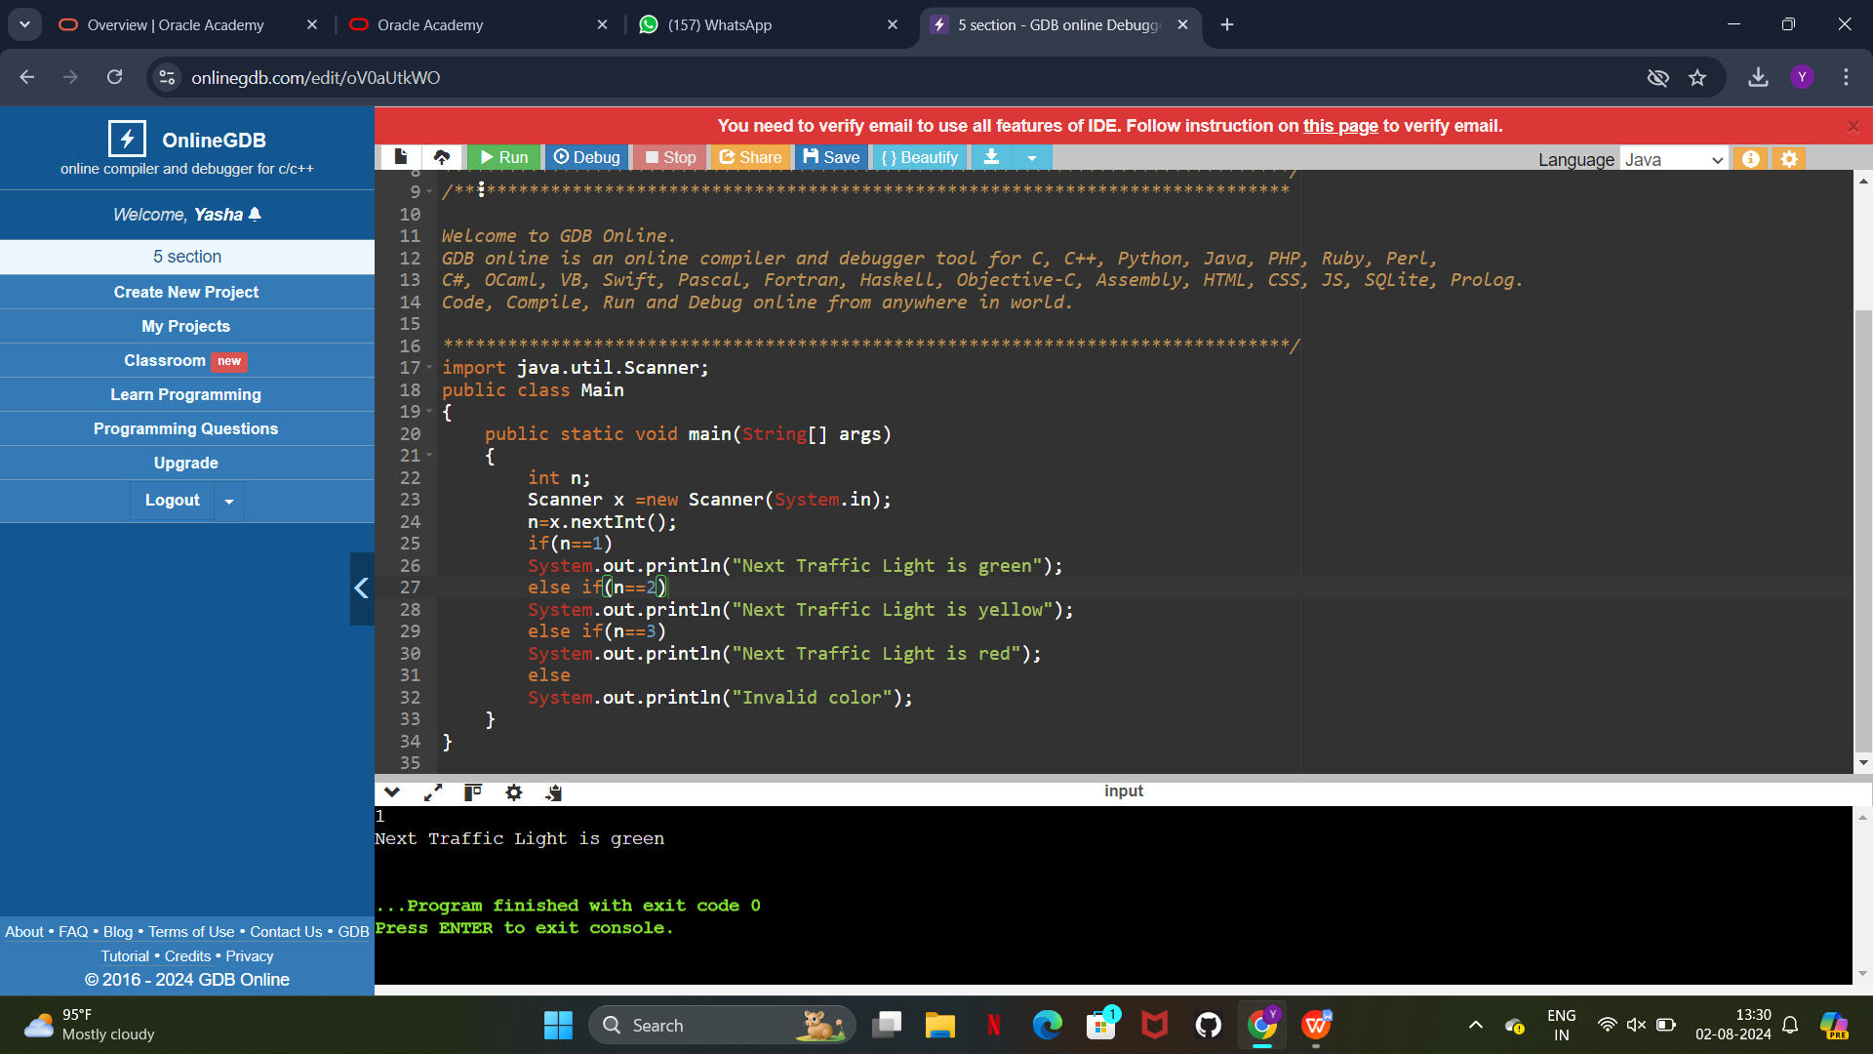

1. **TRAFFIC SIGNAL SWITCH CASE :**

import java.util.Scanner;

public class Main

{

public static void main(String[] args)

{

int n;

Scanner x =new Scanner(System.in);

n=x.nextInt();

switch(n)

{

case 1:

System.out.println("Next Traffic Light is green");

break;

case 2:

System.out.println("Next Traffic Light is yellow");

break;

case 3:

System.out.println("Next Traffic Light is red");

break;

default:

System.out.println("Invalid color");

}

}

}

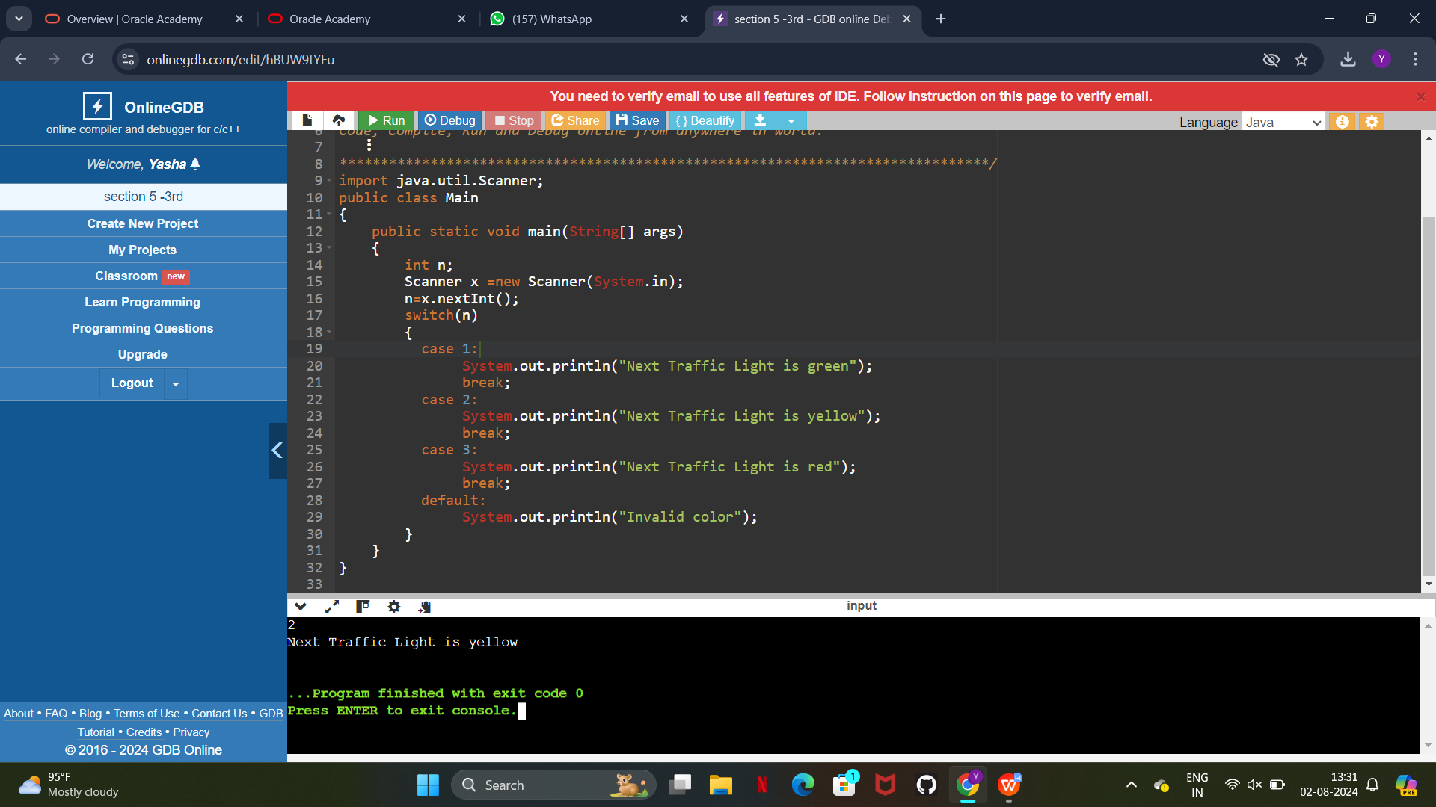

**SECTION 6 :**

1. **ATM PIN :**

import java.util.Scanner;

public class Main

{

public static void main(String[] args)

{

int a,n,m=1234;

Scanner x =new Scanner(System.in);

n=x.nextInt();

if(n==m)

{

System.out.println("User has access to their account");

}

else

{

System.out.println("Pin is incorrect Enter again");

while(n!=m)

{

Scanner y=new Scanner (System.in);

a=y.nextInt();

if(a==m)

{

System.out.println("User has access to their account");

}

else

{

System.out.println("Pin is incorrect Enter again");

}

}

}

}

}

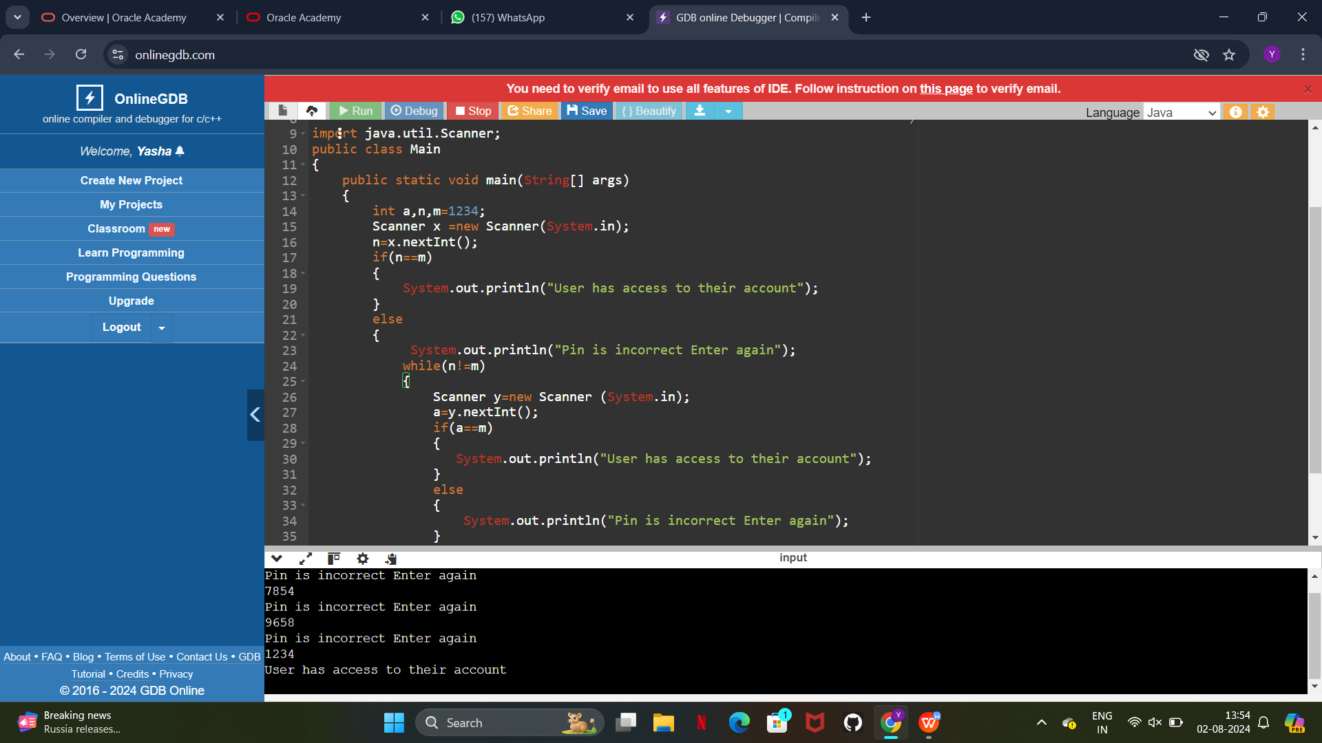

1. **MULTIPLICATION TABLE :**

import java.util.Scanner;

public class Main

{

public static void main(String[] args)

{

int n,i;

Scanner x =new Scanner(System.in);

n=x.nextInt();

for(i=1;i<=12;i++)

{

System.out.println(i+" * "+n+" = "+n*i);

}

}

}

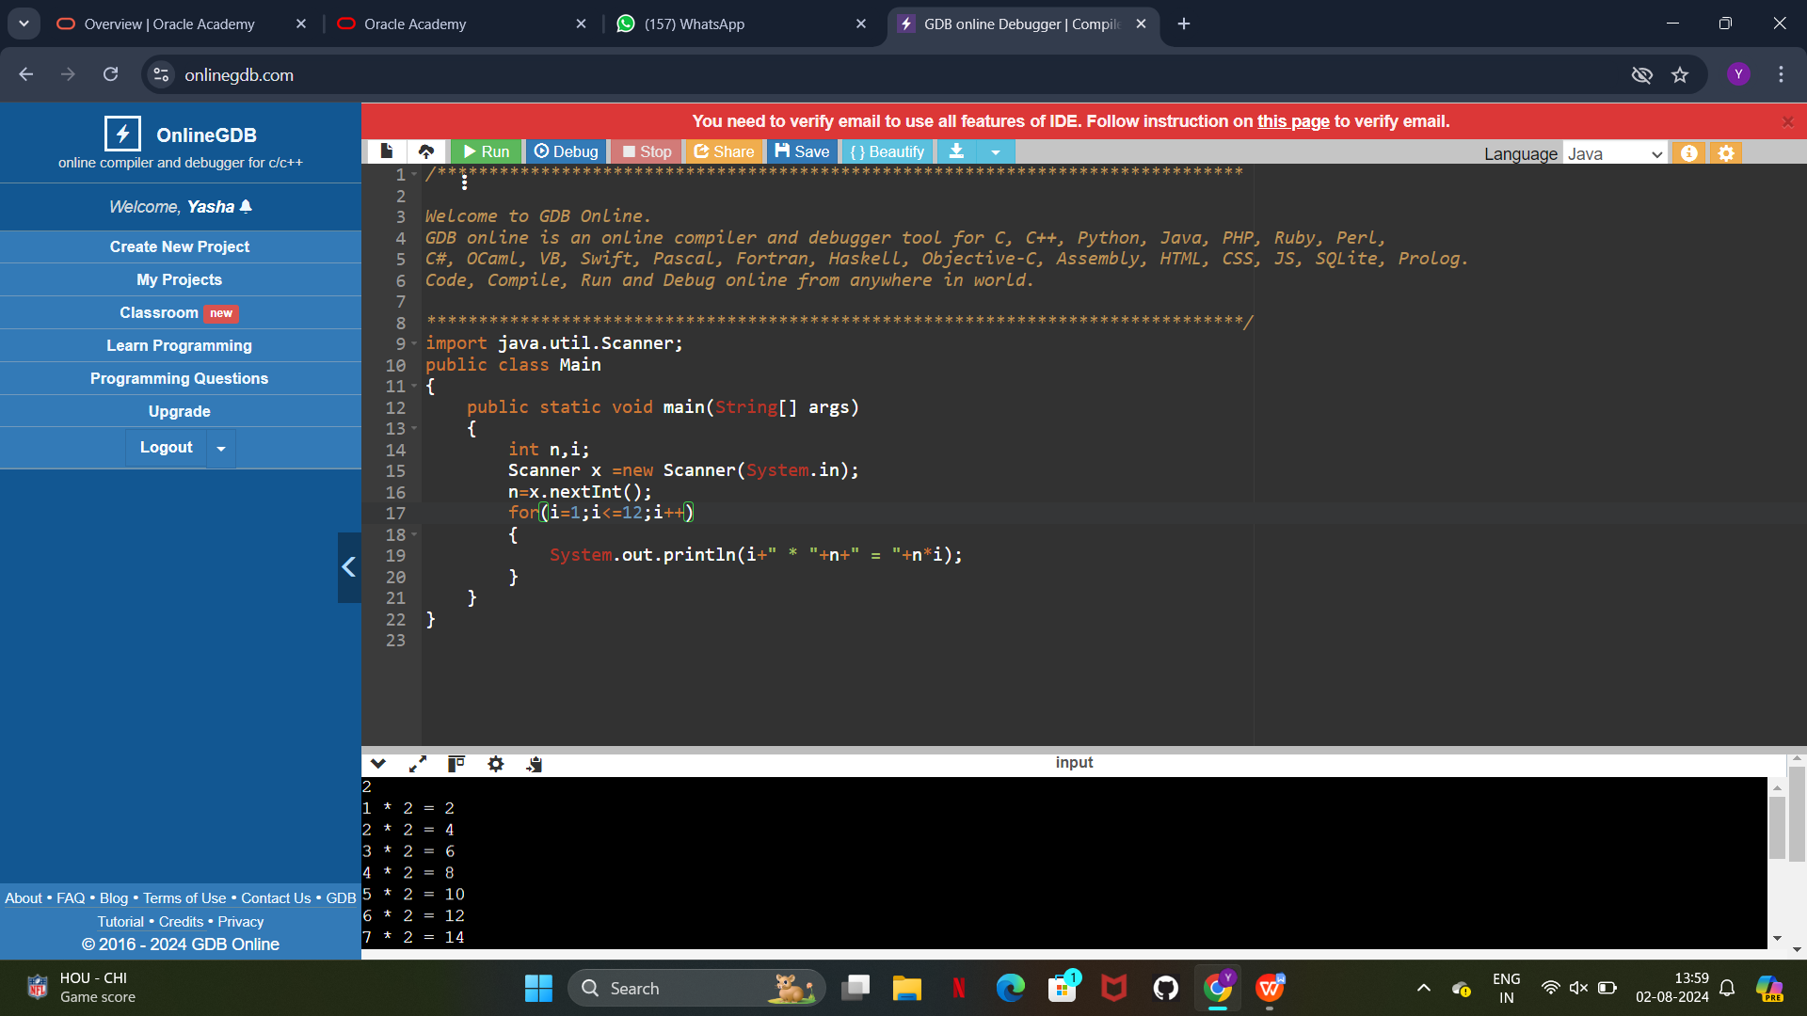

1. **HOLLOW RECTANGLE :**

public class Main

{

public static void main(String[] args)

{

int n=5,i,j,m=10;

for(i=1;i<=n;i++)

{

for(j=1;j<=m;j++)

{

if(i==1||i==n||j==1||j==m)

{

System.out.print("* ");

}

else

{

System.out.print(" ");

}

}

System.out.println();

}

}

}

